Neural Network and Deep learning: ICP/assignment-4

Mallika Mamidi

700746126

Github: <https://github.com/mallika76/NN-ICP-Assignment4.git>

Video Link: <https://drive.google.com/file/d/1V3CZVghrriC5-sDqUr10deRdLhR9dYFM/view?usp=sharing>

I have used the given source code Autoencoder.py and performed the in programming assignment in the given code itself.

1. Import all the required libraries and define the input placeholder which represents the input data for the autoencoder which has a shape of (784,).

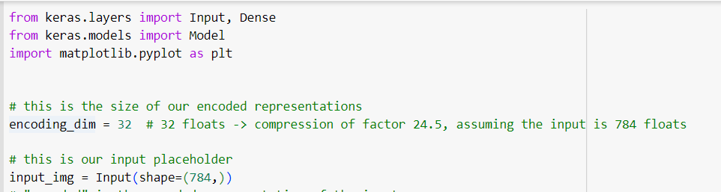

1. Proceed to create the encoder and decoder parts of the autoencoder and include an additional dense layer in both the encoder and decoder parts of the autoencoder with relu and sigmoid activation function respectively.

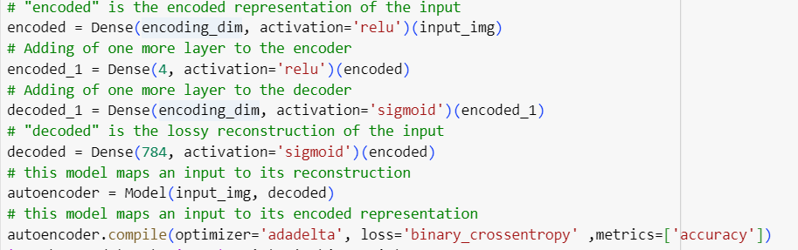

1. load the Fashion MNIST dataset, normalize the pixel values and Visualize the data before reconstructing

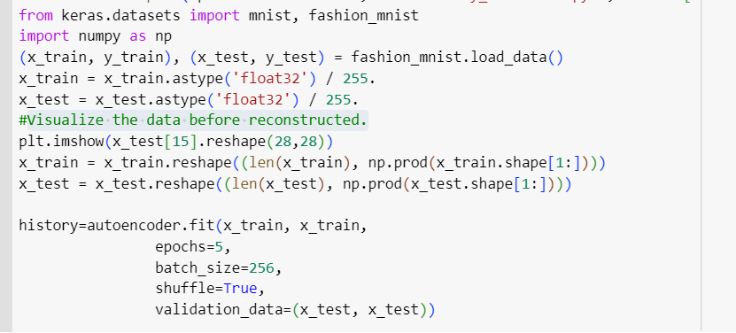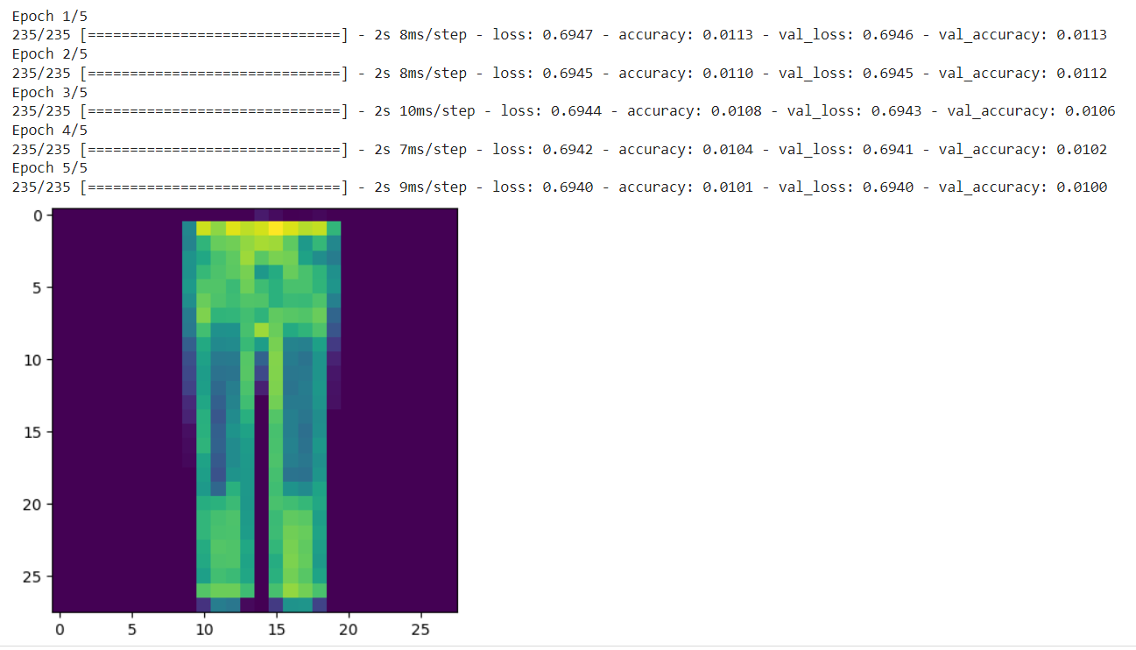.

1. Visualize the data after a reconstructed version of that test data.

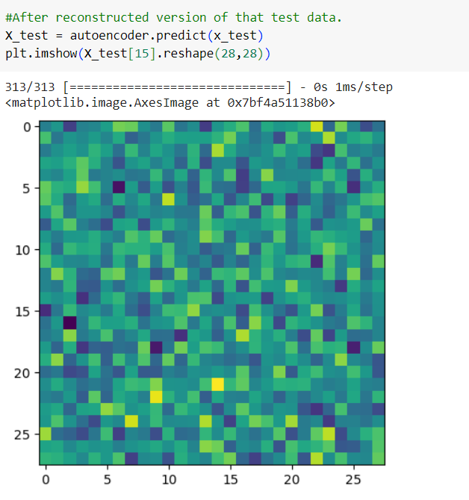

Denoising Autoencoder

1. Import all the required libraries and define the input placeholder which represents the input data for the autoencoder which has a shape of (784,).

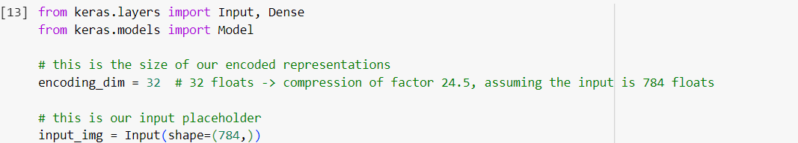

1. Proceed to create the encoder and decoder parts of the autoencoder, and then combine them into a single model

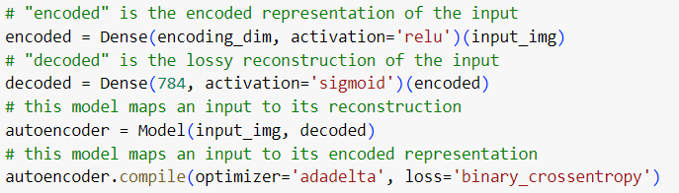

1. load the Fashion MNIST dataset, normalize the pixel values and Visualize the data before reconstructing

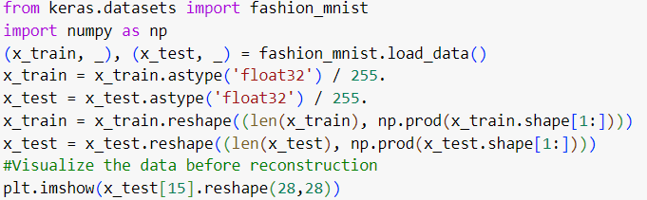

1. Introducing the random noise to the data and evaluate the performance of the denoising autoencoder .

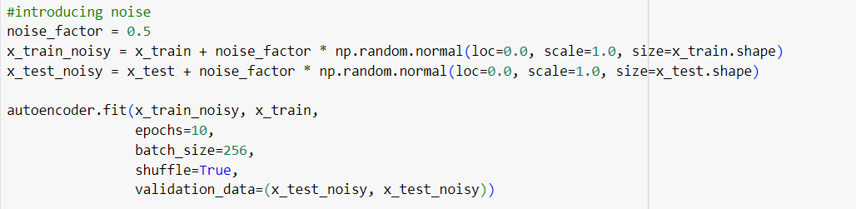

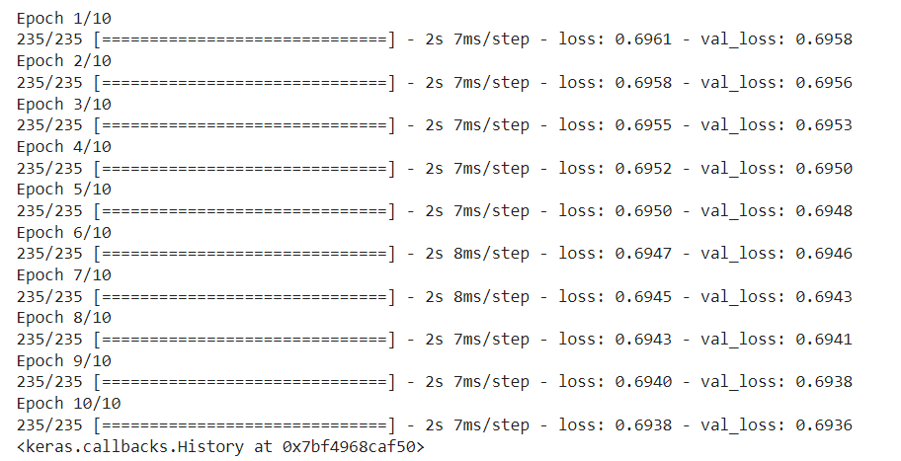

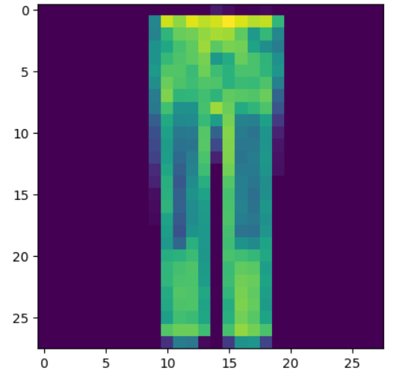

1. Visualize the data after a reconstructed version of that test data.

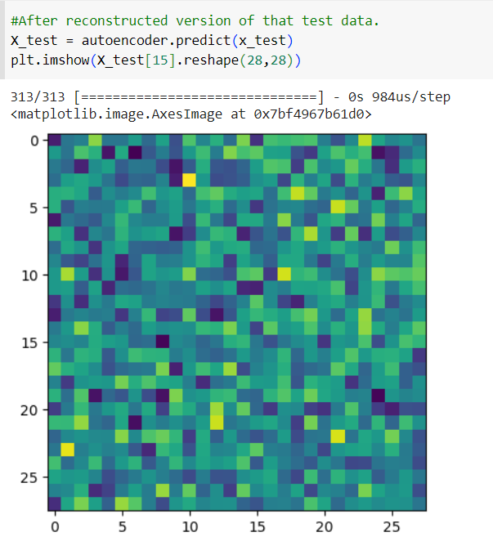

1. Plot loss and accuracy using the history object

